SwiM & STEM with Otters
(Answer Sheet)

Mass of water polo ball
- The water polo ball is characterized by a bright yellow colour and is usually held with one hand despite its large size.
Choose the correct statement:
- To have better grip, friction must be increased.
- To have better grip, friction must be decreased.

- Originally, in the 19th century, water polo used to be played with a leathery ball. A leather ball is not ideal ball because it:
Choose the correct statement:
- Absorbs water and becomes slippery when wet.
- Absorbs water and becomes lighter.
- Is a weak material and is easily torn.

- The minimum mass of a ball used during a particular water polo match is LESS THAN 0.5 kg. When the mass of the ball is converted in grams, the answer is a COMMON MULTIPLE of 8 and 100. It is NOT 200g. What is the MINIMUM MASS of a ball used in water polo?
Common multiples of 8 and 100 are:
200, 400, 600 etc
But since the mass of the ball is less that 500g and since the mass is not 200g, the answer is 400g.

- The DIFFERENCE between the minimum and maximum mass of a ball used in water polo is 50g. What is the MAXIMUM MASS of a ball used in water polo in grams?
400g +50g = 450g

- Write the number that is HALFWAY between the minimum and maximum mass of a water polo ball.
400g + 450g = 950g
950g $÷$ 2 = 425g

THE FOURTH DIGIT of the code is the TENS VALUE OF THE ANSWER ABOVE! What is the FOURTH digit of the code? (2)

Time of water polo match

- The game of water polo consists of 4 parts of 8 minutes each. HOW LONG in minutes do the parts last all together?
8 x 4 = 32 minutes

- Usually each quarter lasts longer because the clock is stopped when the ball is not in play. In a particular match between Otters ASC and Nautic ASC the MEAN TIME of each quarter was 11 minutes. The first quarter lasted 11 minutes. The second quarter lasted 11 minutes. The third quarter lasted 12 minutes. HOW LONG in minutes did the fourth quarter last?
If the mean was 11 minutes, the total time of the game was 11 x 4 = 44 minutes.
The total time of the first, second and third quarter is $11+ 11 +12=34$ minutes.
Time of fourth quarter is $44- 34=10$ minutes

- HOW LONG was the ball NOT in play in the fourth quarter?
10 – 8 = 2 minutes

THE THIRD DIGIT of the code is the same as the ANSWER ABOVE! What is the THIRD digit of the code? (2)

Area of water polo pitch

- The area of the water polo pitch is 600$m^{2}$. The shape of the water polo pitch is that of a rectangle. Both the length and breadth are multiples of 10. The difference between the length and breadth is LESS THAN 40m. What is the length of the longest side of the water polo pitch in m?
Area = Length x Breadth
If both length and breadth are multiples of 10, we have to find the multiples of 10 that when multiplied together make 600 (or factors of 600).
Either 10 x 60 = 600$m^{2}$
Or 20 x 30 = 600$m^{2}$
Since the difference between the length and breadth is less than 40m, the dimensions are 20$m$ x 30$m$.
Therefore the longest side is 30$m$.

- The length of the net is 1/10 the length of the longest side of the rectangle. Find the length of the net.
$\frac{1}{10} ×30=3m$

- The net is placed in the shortest side of the water polo pitch. Find the DIFFERENCE between the length of the shortest side of the water polo pitch and the length of the net.
20$m-3m=17m$

THE SECOND DIGIT of the code is the UNITS VALUE OF THE ANSWER ABOVE! What is the SECOND digit of the code? (7)
Otters ASC and leap years
- Otters ASC was founded 50 YEARS AGO. Which YEAR was otters ASC founded?
2021 – 50 = 1971

- Which year was the FIRST leap year AFTER Otters ASC was founded?
A leap year happens every 4 years and is always a multiple of 4. But not all multiples of 4 are necessarily a leap year.
Since a leap year happens every 4 years, somewhere from 1972 to 1975 there has to be a leap year.
Check which of 1972, 1973, 1974 and 1975 are leap years?
Only 1972 is divisible by 4 so only 1972 is a multiple by 4.
Also, last year was a leap year.
2020 – 4 = 2016
2016 – 4 = 2012
2012 – 4 = 2008 etc etc

- HOW MANY leap years have passed after Otters ASC was founded?
1972, 1976, 1980, 1984, 1988, 1992, 1996, 2000, 2004, 2008, 2012, 2016, 2020
13 leap years

THE FIFTH DIGIT of the code is the same as the UNITS VALUE OF THE ANSWER ABOVE! What is the FIFTH digit of the code? (3)

Swimming (Forces)
Choose the correct statement in each of the questions below:

- The water polo caps are used to identify both the player and their team. Moreover, the cap is streamlined and as a result it:
- creates less of a drag in the water.
- Increases friction with water.
- Gives a more sophisticated look to the swimmers.

- The water cap helps the player to swim (faster, slower).

- While swimming the player strokes the water. As the player strokes the water backwards, he will move (forward, backward, sideways).
THE FIRST LETTER of the code is the same as the SECOND LETTER OF THE ANSWER ABOVE! What is the FIRST letter of the code? (O).

Towels (Materials)
- The players dry up with a towel immediately after they come out of the water. They do so as:
- they start to feel cold due to evaporation of water from their bodies which leads to a decrease in temperature.
- They do not like to feel wet.
- Evaporation of water from their bodies leads to an increase in temperature.

Towels absorb water. Find out which of the following materials absorb water best.

- For this investigation you will need kitchen paper towel, baking paper and printing paper.
- Cut out 3 rectangles, one of each material, measuring 10cm by 5cm.
- Make a horizontal mark, 3cm from the bottom on each rectangle.
- Fill 3 containers with equal amounts of water.
- Insert the kitchen paper rectangle in the water, such that the water reaches the mark (not more). Repeat this step for the baking paper rectangle and the printing paper rectangle. (The three rectangles should be immersed in the water at the same time).
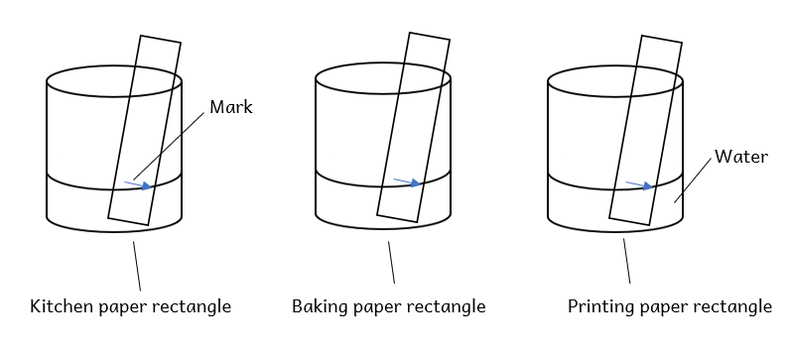
- Leave the paper rectangles immersed in water for at least 30s as shown in the diagram.
- Observe which material absorbs most water. (You may measure the distance travelled by the water, if any, in each rectangle).
Continue the sentence below:
__Kitchen Paper_____ is the best absorber of water.
The first letter of the answer is the last letter of the code. (K)

Sea Water and Fresh Water
- The lockers in the changing room are made of iron. Iron is a strong material. However, players play in the sea and when they enter the changing room the salt on their hands may be deposited on the lockers.
Choose the correct statement:
After a period of time, the lockers:
- Rust
- Get stronger.
- Remain unchanged.

- In order to avoid the above, the lockers can be:

- galvanized. (Galvanized is when they are coated with a protective layer of zinc.)
- covered with grease.
- Covered with paint.
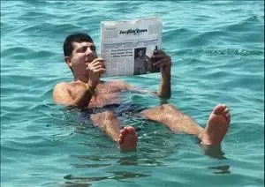
- All of the above are correct.
- It is easier for the water polo players to play in sea water rather to fresh water. (True or False)

- The sea is the habitat of various living things. We need to take care of our sea by:
- Not throwing rubbish into the sea.
- Reduce overfishing.
- Stop using single use plastics.
- All of the above.
- If a plastic bottle is thrown into the sea this year (2021), in which year will it decompose?
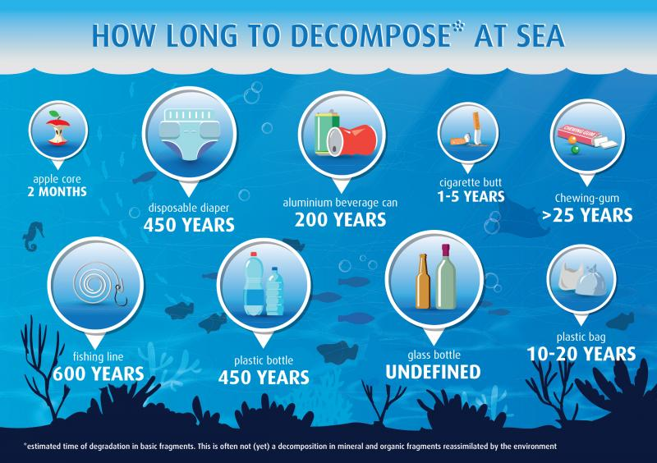

A plastic bottle takes 450 years to decompose.
2021 + 450 = 2451
THE FIRST DIGIT of the code is the UNITS VALUE OF THE ANSWER ABOVE! What is the FIRST digit of the code? (1)

The Code is 17223OK

