  Top tips!
  - Do some background research on viaducts (aqueducts) to get to know what they were used for in the past
  - Make a sketch of your design in your booklet before you start building!
  - Think about how you will be connecting the pipes to avoid any leakages.
  - How will water travel? Think about the height of your viaduct. Should it be built on one level or should it be constructed with a gradual slope?
  Viaducts
  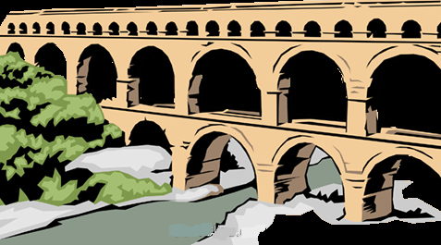
  Science & Technology Challenge
    - Name: ________________________________________________________________

  Materials needed  - Ten plastic pipes  - Two easy elbows  - Two 90⁰ elbows  - 24 wooden dowels  - Rubber bands  - Water jugs  Rules  - You have to build an aqueduct with the materials provided.  - 500ml of water will be poured from one end of the aqueduct. Your structure must not leak any water so that 500ml will reach the other end.  - The task is to build the longest aqueduct structure. Water must not leak in any way. |  |  | Plan & design your viaduct!

