  Top tips!
  - Do some background research on balloon-powered cars to get inspired!
  - Make a sketch of your design on paper before you start building!
  - Attaching the neck of the balloon to a "bendy" straw using a rubber band makes it easier to attach the balloon to your car, to inflate the balloon, and to aim the direction of the air escaping the balloon.
  - The axles should rotate freely. Inserting a skewer through a drinking straw would work well!
  - Wheels usually work better if they are centered on the axles and do not wobble!
  Balloon Powered Car
  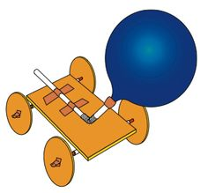
  Science & Technology Challenge
    - Name: ________________________________________________________________

  Suggested materials  - A balloon or balloons!  - For the body – plastic bottle, plastic cup, Styrofoam (jablo), cardboard, cereal box.  - For the wheels – CDs, buttons, bottle caps (a small hole has to be made in the centre before the activity), empty rolls of tape.  - For the axles – pencils or skewers (kebab sticks)  - To connect wheels to axles – plasticine  - To connect axles to the car’s body – plastic drinking straws  - Other suggested materials – glue, tape, paper clips, rubber bands, scissors.  Rules  - The car must travel straight.  - The car should go as far as possible. |  |  | Plan & design your car!

