Strand: Energy
Forces

Learning Outcomes:
6.5.2 Know that air resistance can slow down the movement of objects

Learning Objective:
The children will be able to:
- describe how their car is designed to travel as far as possible;
- refer to the concept of air resistance and friction to describe what might help their car travel further;
- explain what causes the balloon car to start moving, using ideas of action and reaction forces;
- explain that the car will continue to move, even if the balloon is out of air, until it is slowed down by friction.

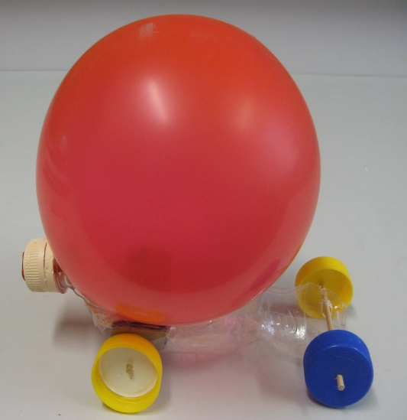

Lesson activity: Design and make a balloon-powered car

Resources:
- Children’s own materials for the balloon-powered car e.g. plastic bottle, bottle caps, cardboard, straws, kebab sticks etc.
- Other basic tools e.g. glue gun, tape, butterfly pins, scissors and a stapler.

ENGAGE
Blow up a balloon without tying its end. Let it go in the class. What is making the balloon dart around the class? Why does the air go out one way and the balloon move in an opposite direction? The idea of air causing movement is introduced and discussed e.g. sails, parachute. The idea of a car which moves by air pressure is introduced and discussed.

DESIGN and MAKE

- Explain the challenge to the class. Show the children various videos of balloon powered car models. Groups are to discuss and sketch their model. They will have 1 week to gather materials and tools and bring them to school to build a balloon-powered car next lesson.

- In the following lesson, the different groups assemble and build their own balloon–powered car and test it out. Discuss with various groups some variables that might affect how far the car travels e.g. streamlining, type of wheels, weight. They will have the opportunity to modify their model to make it more efficient. When all groups are satisfied with their models, they will test the cars in a race.

- Assess the circuit setup and components.
- Set up the simple circuit and note that it works.
- If it does not work assess the situation. Check battery, wire connections, bulb and holders.
- Repeat the process till the circuit works.

Building the model
Follow the instructions as outlined in the pictures below. These are a step by step process of how to design and sketch your model.
- Cut out the model.
- Colour and decorate the model.
- Glue on to card.
- Prepare a stand or base.
- Set up the model on stand.
- Fit the circuit into the model or stick the whole circuit.

ASSESS and EVALUATE

After the race, children will evaluate the various models and draw out reasons why some were faster than others e.g. the wheels offered too much friction, the chassis of the car was too heavy. Discuss the various science ideas using keywords such as ‘friction’, ‘air resistance’. Encourage the children to find a solution to improve their model.
Cross-Curricular Links:
- Literacy:
- Writing instructions on how to make such a model.
- Oracy – discussing the process of building the model.
- Creative Arts:
- Making the car aesthetically more attractive.
- Social Studies:
- Discuss how cars can be more eco-friendly
- Maths:
- Measuring distances

