  Top tips!
  - Do some background research on designing structures.
  - Which shapes will make the structure stronger? Squares, rectangles, triangles or circles?
  - Will rolling the newspapers diagonally make a stronger structure than folding them?
  - How will you join the different parts of the structure?
  - How could you make your structure better?
  Christmas Shelter
  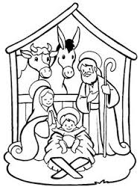
  Science & Technology Challenge
    - Name: ________________________________________________________________

  Suggested materials  - Newspapers  - Tape  - Christmas decorations  Rules  - Free standing shelter.  - Use newspaper and tape only.  - One member of the team must fit in the shelter.  - Decorate the shelter for Christmas. |  |  | Plan & design your shelter!

