  Top tips!
  - Think about the design for your boat.
  - Would it be best to make a small boat or a big boat?
  - Which shape should the boat have?
  - Should you fold the edges?
  - Use the 3 pieces of aluminium foil to try different designs.
  - Before adding the nuts, try to predict how many nuts your boat can hold before it sinks!
  - Put the nuts, one at a time, in the middle of the boat first, then work your way towards the outsides, so that the boat will not topple over!
  - Which design holds most nuts?
  Aluminium Foil Boats
  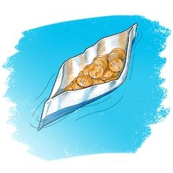
  Science & Technology Challenge
    - Name: ________________________________________________________________

 | Materials needed  - 3 pieces of aluminium foil measuring 20cm by 20cm.  Rules  - Form the boat shape by hand.  - No tape or glue should be used.  - The boat holding the greatest number of nuts will win!  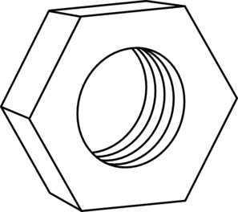  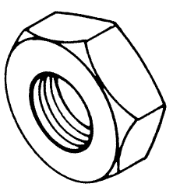  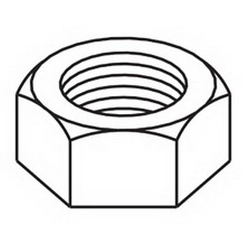  Results! |  |  | Plan & design your boat!
  Boat design | Predicted number of nuts | Actual number of nuts

