Strand: Learning Outcome 3
What is energy?

Learning Outcomes:
3.1.12 I can follow written or verbal instructions related to keeping safe.
3.1.13 I can work on an experiment in a group under adult supervision.
3.5.2 I can describe the role of electricity in everyday life.
3.5.3 I can describe what life was like before electricity.
3.5.4 I can identify ways of limiting energy use at home and at school.
3.5.5 I can build a simple electric circuit and show that all parts need to be connected.

Learning Objective:
By the end of the lesson, children can acquire skills such as using the scissors correctly, applying glue, making holes in card and observing safety rules.

Lesson activity: Build a model with an electric circuit

Resources:
- Wires, bulbs, LEDs, battery holders, bulb holders, wire stripper
- Card
- Glue
- Scissors
- Tape
- Colours
- Decorative stickers

ENGAGE
Encourage children to set up a simple circuit using wires, batteries, battery holders, bulb holders to revise what was done in previous lesson (LO 3.5.2).

The learners will investigate how to use this circuit to make a working model light up, for example a lighthouse model, a Christmas tree, a Snow man, Santa Claus, Crib, Star, and any more models of their own imagination.

DESIGN and MAKE
- Assess the circuit setup and components.
- Set up the simple circuit and note that it works.
- If it does not work assess the situation. Check battery, wire connections, bulb and holders.
- Repeat the process till the circuit works.

Building the model
Follow the instructions as outlined in the pictures below. These are a step by step process of how to design and sketch your model.
- Cut out the model.
- Colour and decorate the model.
- Glue on to card.
- Prepare a stand or base.
- Set up the model on stand.
- Fit the circuit into the model or stick the whole circuit.

ASSESS and EVALUATE
Assessment will take place throughout the lesson. Encourage children to find a solution if the circuit does not work well. Children should discuss and reflect on how the circuit should be connected.
The following questions can help children assess their models:
1. What do I like about my model?
2. Is the circuit connected and attached correctly to the model?
3. What can be improved?

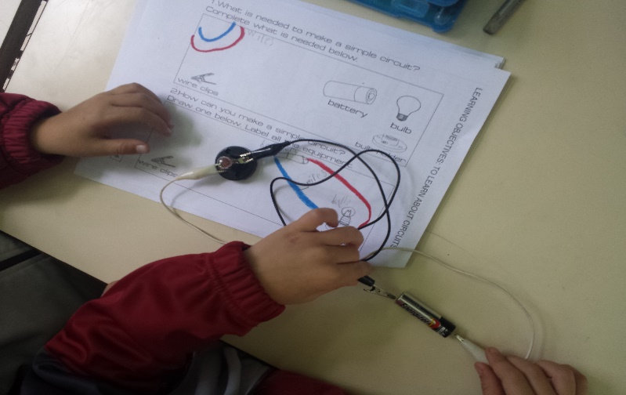
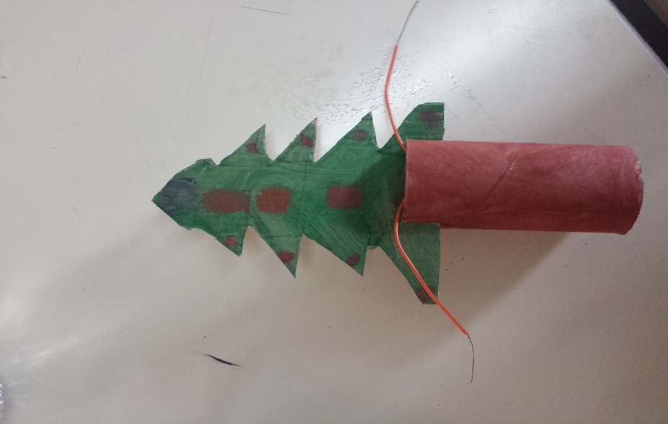
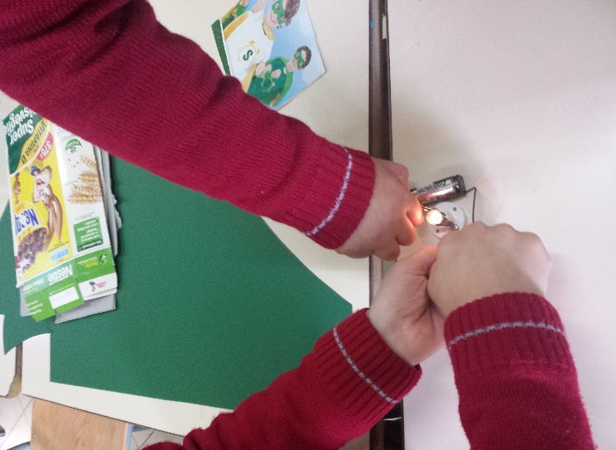
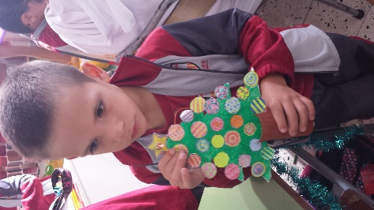
Cross-Curricular Links:
- Literacy:
- Writing instructions on how to make such a model.
- Oracy – discussing the process of building the model.
- Creative Arts:
- Artwork related to the model chosen.
- Social Studies:
- Use of Light Houses in Malta.

