Strand: Energy / Materials Around Us
How will your picture move?

Learning Outcomes:
2.5.1 Know that a push or a pull can make things change direction, or stop or go faster or slower.
2.10.1 Identify some common materials.

Learning Objective:
By the end of the lesson children will appreciate how movement makes a picture come to life; go through the design process of researching, observing, testing, evaluating and improving the moving model; acquire skills such as using the scissors correctly, applying glue, making holes in card and observing safety rules.

Lesson activity: How will your picture move?

Resources:
- 5 ready-made moving pictures eg. of a clown.
- Pictures from drawing books
- Empty cereal boxes
- Glue
- Scissors
- Tape
- Colours
- Butterfly clips

ENGAGE
Show pictures of a still object, for example a clown. Discuss about what do they observe about the picture. Show another picture this time with a moving part. How is the second picture better than the first one?

ELICIT - (pass the moving pictures around)
Children will observe and investigate what is causing the movement of the moving picture.
What is the function of the lever?
What do you notice about the overlapping parts?
Why do we use butterfly pins?

DESIGN and MAKE
- Choose a picture from the drawing books or draw a model.
- Decide which part of the picture will move.
- Plan how the lever will be designed.
- Sketch where the butterfly pins should be fixed.

Making the moving picture
Follow the instructions as outlined below. These are a step-by-step process of how to design and make the moving picture.
- Colour and decorate the picture.
- Cut out the moving part, glue it to the cereal box and sketch the lever part.
- Glue the non-moving part on to the cereal box.
- Cut out both pictures.
- Insert the butterfly pin/s.
- Test the movement of the moving picture.

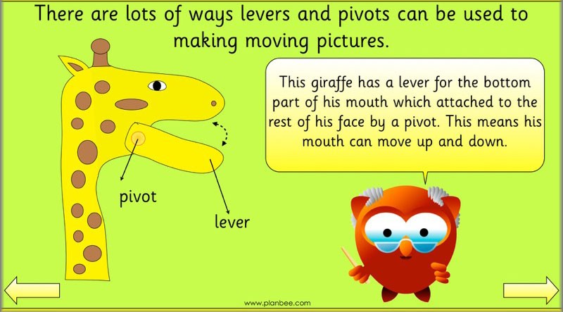
Cross-Curricular Links:
- Literacy:
- Writing instructions on how to make such a moving picture.
- Oracy – discussing the process of creating the moving picture.
- Creative Arts:
- Artwork related to the moving picture chosen.
ASSESS and EVALUATE
Assessment will take place throughout the lesson. Encourage children to find a solution if the moving picture does not work well.

The following questions can help children assess their moving picture:
- Did you get the desired movement?
- What do I like about my moving picture?
- Is the lever properly fixed?
- What can be improved?

