Strand: Sharing Our World
Habitats

Learning Outcome:
1.3.1 Observe the many features that make the environment around us.

Learning Objective:
By the end of the lesson children will be able to match plants and animals to their different habitats; appreciate how a movement makes a model come to life; go through the design process of researching, observing, testing, evaluating and improving the moving model; acquire skills such as using the scissors correctly, applying glue, making holes in card and observing safety rules.

Lesson activity: How will your model move?

Resources:
- a ready-made moving model eg. an aquarium (see picture below).
- Pictures of animals (related to the chosen habitat eg. ocean, desert, rainforest, etc.)
- Empty cereal boxes
- Glue
- Scissors
- Tape
- Colours
- String
- Buttons/caps/cork or something similar

ENGAGE
Show them and discuss the model. Before demonstrating the movement of the animals, elicit how can they make the animal pictures move.

ELICIT
Children will observe and investigate what is causing the movement of the animals.
What is the function of the button/cap/cork etc.?
What do you notice about the slots?

DESIGN and MAKE
- Choose a habitat, for example the ocean, desert, rainforest, etc.
- Decide which animals live in that particular habitat.
- Plan how will the animals move.
- Sketch where the slot shall be cut.

Making the model:
Follow the instructions as outlined below. These are a step-by-step process of how to design and make the model.
- Cut one side of the cereal box, (refer to picture below). Keep the remaining part as this will be used in step 3.
- Colour the animals and decorate the cereal box related to the chosen habitat.
- Glue the animals on the remaining part of the cereal box.
- Cut out the animals.
- Poke a hole at the top of each animal and attach a string to it.
- Insert the other side of string in the slots of the cereal box and tie each string to the buttons/caps/corks etc.
- Test the movement of the animals.

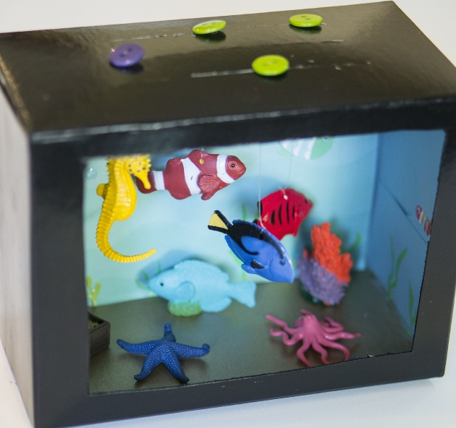
Cross-Curricular Links:
- Literacy:
- Writing instructions on how to make such a model.
- Oracy – discussing the process of creating the model.
- Oracy – discussing different habitats

- Creative Arts:
- Artwork related to the model chosen.

- Science
- Learn about different animals and their respective habitats

ASSESS and EVALUATE
Assessment will take place throughout the lesson. Encourage children to find a solution if the model does not work well.

The following questions can help children assess their model:
- Did you get the desired movement?
- What do I like about my model?
- Is the string properly fixed?
- What can be improved?

